Ideation Phase
Brainstorm & Idea Prioritization Template

Date | 20 February 2026
Team ID | LTVIP2026TMIDS80887
Project Name | FreelanceFinder: Discovering Opportunities, Unlocking Potential
Maximum Marks | 4 Marks

Brainstorm & Idea Prioritization Template:

Step-1: Team Gathering, Collaboration and Select the Problem Statement

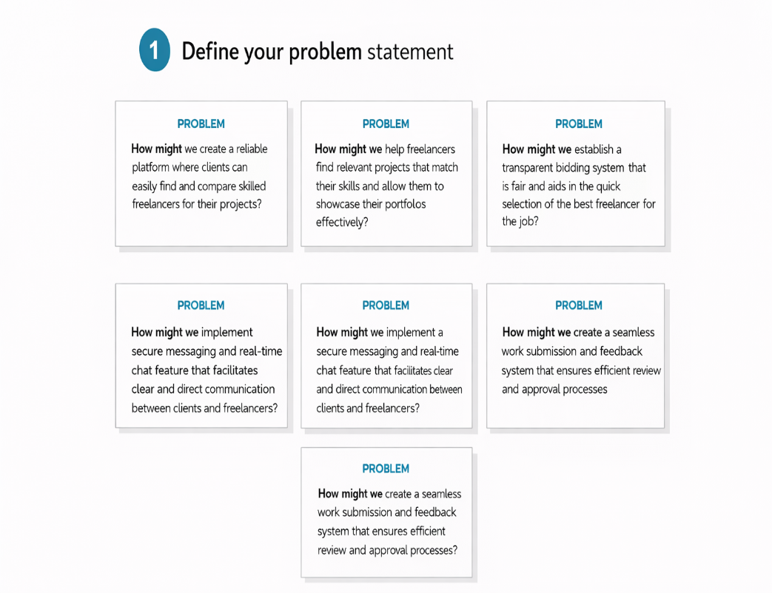

Step-2: Brainstorm, Idea Listing and Grouping

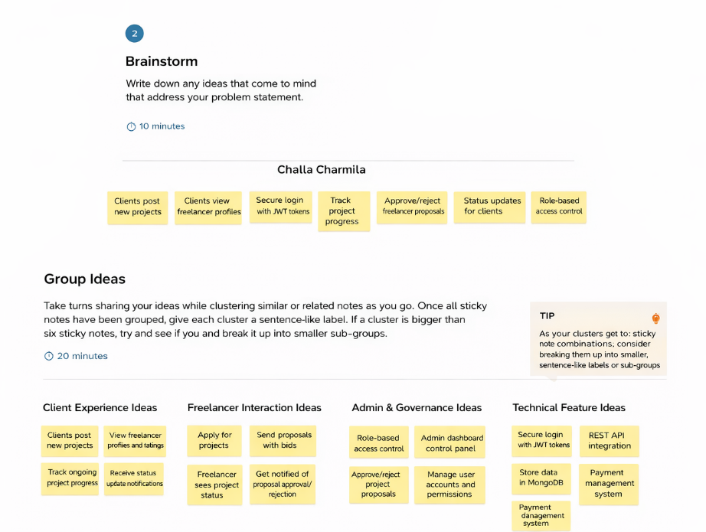

Step-3: Idea Prioritization

